Week 5 – Loops
Vocabulary (5 mins)
Iteration:
Infinite Loop:

Quiz – Good or Error? Common Mistakes for Beginners (15 mins)
1, 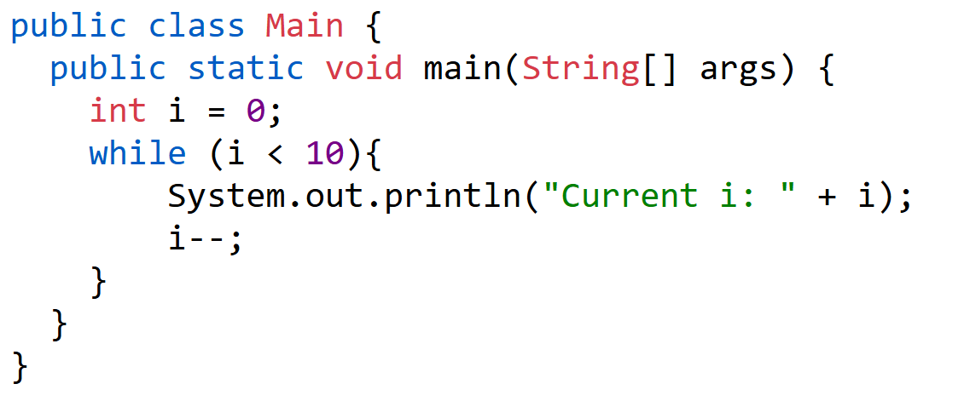
2. 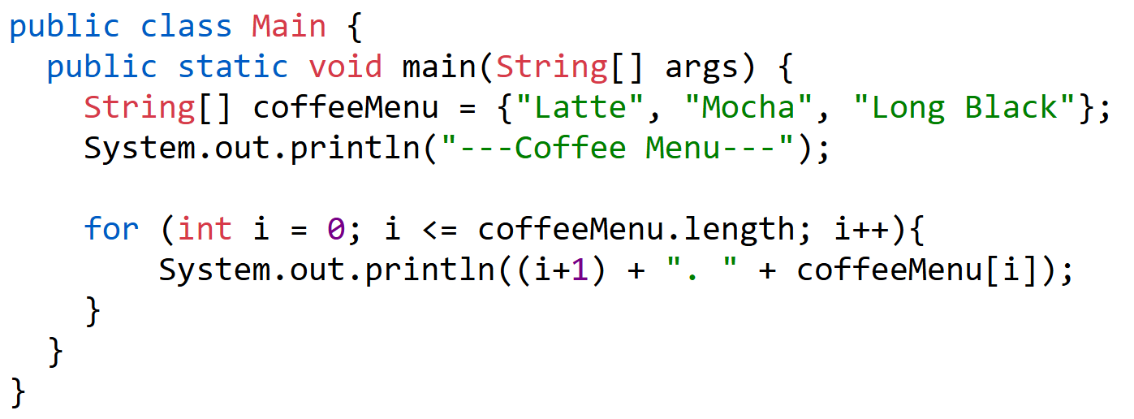
3. 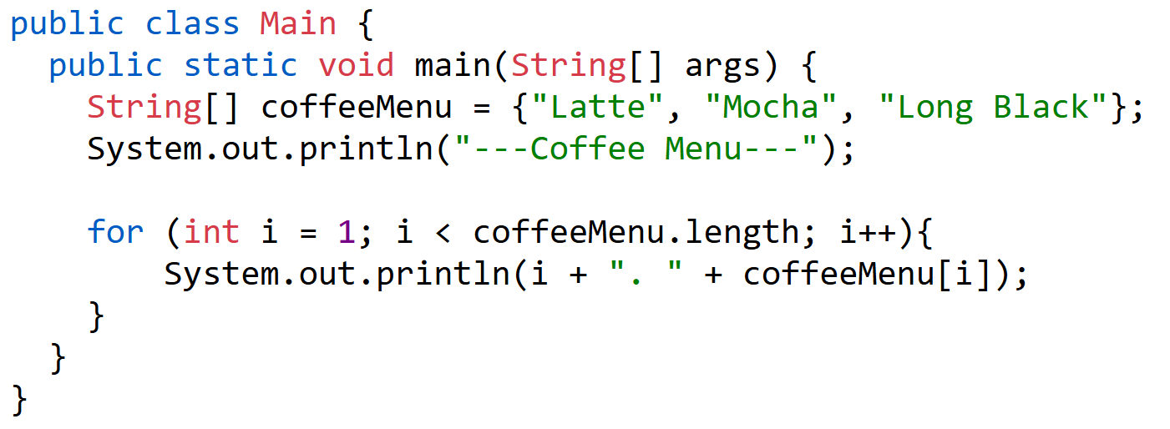

Activity – While Loop (15 mins)
Let’s make an example with While loop!
