Week 7 – Classes
Vocabulary (5 mins)
Class:
Object:
Property:

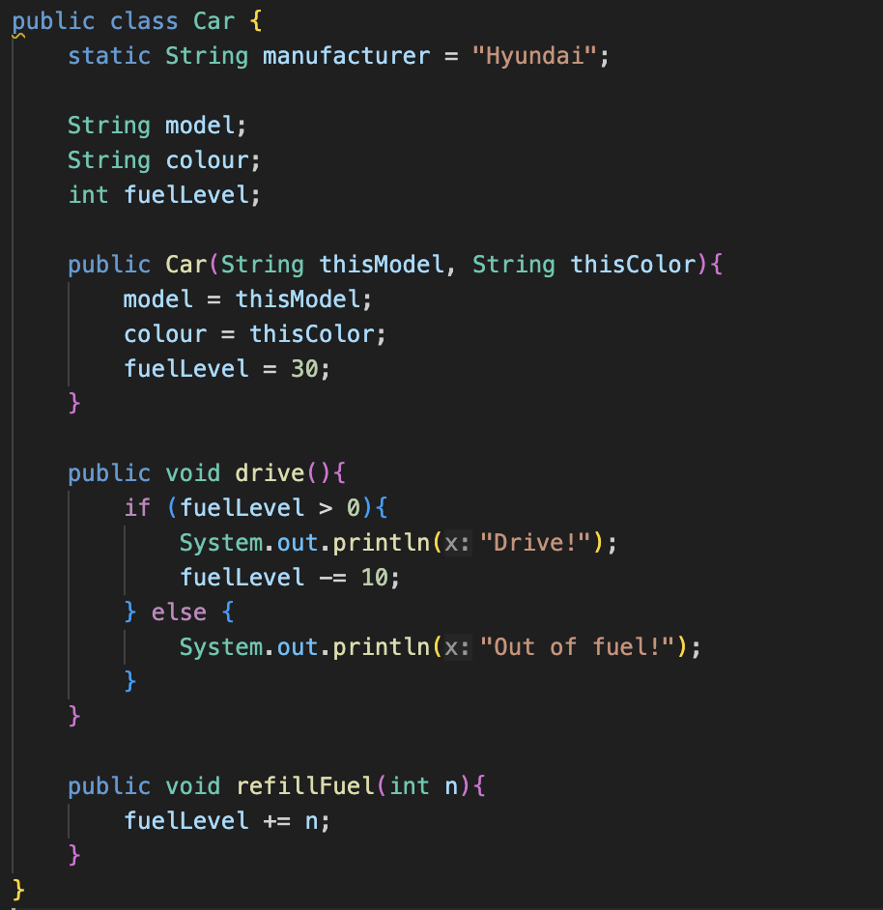
Car.java

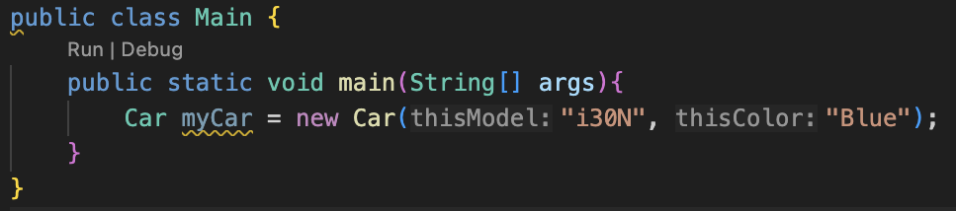
Main.java

Activity : Let’s play around with the Car!
1 : Drive until fuel run out! And refill the fuel.
2 : Add 1 more method (behaviour/action)
3 : Add 1 more local property
4 : Add 1 more global property
5 : Try to change colour. I don’t like this!
6 : Try to change manufacturer…?
7 : My sister wants new car. Can you make new one for her?

